HANOI UNIVERSITY OF SCIENCE AND TECHNOLOGY
School of Information and communications technology

Software Requirement Specification

AN INTERNET MEDIA STORE
Subject: ITSS SOFTWARE DEVELOPMENT

Dinh Viet Quang - 20215235

Hanoi, March - 2024
Table of Contents
1 Introduction 2
1.1 Objective 2
1.2 Scope 2
1.3 Glossary 3
1.4 References 4
2 Overall Description 4
2.1 Survey 4
2.2 Overall requirements 4
2.3 Business process 5
2.3.1 Place order process 6
2.3.2 Pay order process 7
2.3.3 Place rush order process 7
3 Detailed Requirements 8
3.1 Use Case “Place order” 8
3.2 Use Case “Pay order” 10
3.3 Use Case “Place rush order” 12
4 Supplementary specification 15
4.1 Functionality 15
4.2 Usability 15
4.3 Reliability 15
4.4 Performance 15
4.5 Supportability 15
4.6 Other requirements 15

Introduction
The journey towards knowledge, art, and entertainment has always been and will continue to be an integral part of human life. However, life itself is not inherently easy. There will come a time when the fruits of creative labor may struggle to reach people, as artists and intellectuals may find it challenging to sustain themselves with adequate living standards.
Fortunately, in the age of the booming Internet and the Fourth Industrial Revolution, new opportunities have emerged for all of us. One such opportunity is the AIMS Project, an E-commerce system designed for purchasing media products.
This document aims to provide a comprehensive description of the subsystem, user groups, and their functions available during runtime. It outlines the purpose and features of the system, interfaces, and constraints that the system must adhere to in response to external stimuli. The documentation targets stakeholders and software developers alike

Objective
The system enables customers to browse products, add items to their cart, proceed to checkout, make payments for orders, and manage their purchase history. The project aims to offer a hands-on experience for students to enhance their programming and software engineering skills, focusing particularly on web development, database design, and software architecture. Furthermore, the project aims to deepen students' understanding of the e-commerce industry, encompassing both business processes and technical aspects such as payment processing, inventory management, and order fulfillment.

Scope
The software product to be produced is the AIMS Software, which is an online platform for customers to order products and make payments, and for administrators and product managers to manage users, orders, and inventory.
The AIMS Software will allow customers to browse and search for products, add products to their cart, view the invoice before payment, and make payments using a prepaid credit card. Customers will also be able to cancel their orders and receive refunds.
For administrators and product managers, the AIMS Software will provide a view for managing orders, including approving or rejecting pending orders, and updating inventory levels. The software will also enable the addition, deletion, and editing of products in the inventory.
The purpose of the AIMS Software application is to provide customers with a convenient and efficient means of ordering products, while enabling product managers to effectively manage orders and inventory. The relevant benefits include streamlined order processing, improved inventory management, and increased customer satisfaction. The objectives and goals are to create a user-friendly and reliable software system that meets the needs of both customers and administrators. For purchasing purposes, customers will have the option of using a credit card. The transaction will be processed by a third-party payment processing service called VNPay.

Glossary
No | Term | Explanation | Example | Note
1 | AIMS | AIMS stands for "Automated Inventory Management System". It is a software system designed to help businesses manage their inventory and streamline their operations
2 | E-commerce | E-commerce (electronic commerce) refers to the buying and selling of goods and services over the internet.
3 | Customer | A customer is a person or organization that purchases goods or services from a business.
4 | Credit Card | A credit card is a plastic card issued by a bank or financial services company that allows cardholders to borrow funds to purchase goods and services. The borrowed funds must be repaid with interest.
5 | CRUD | Four basic functions, namely Create, Retrieve, Update, Delete

References

Overall Description

Survey
There are three actors including customer, admininistrator andVNPay.

Overall requirements
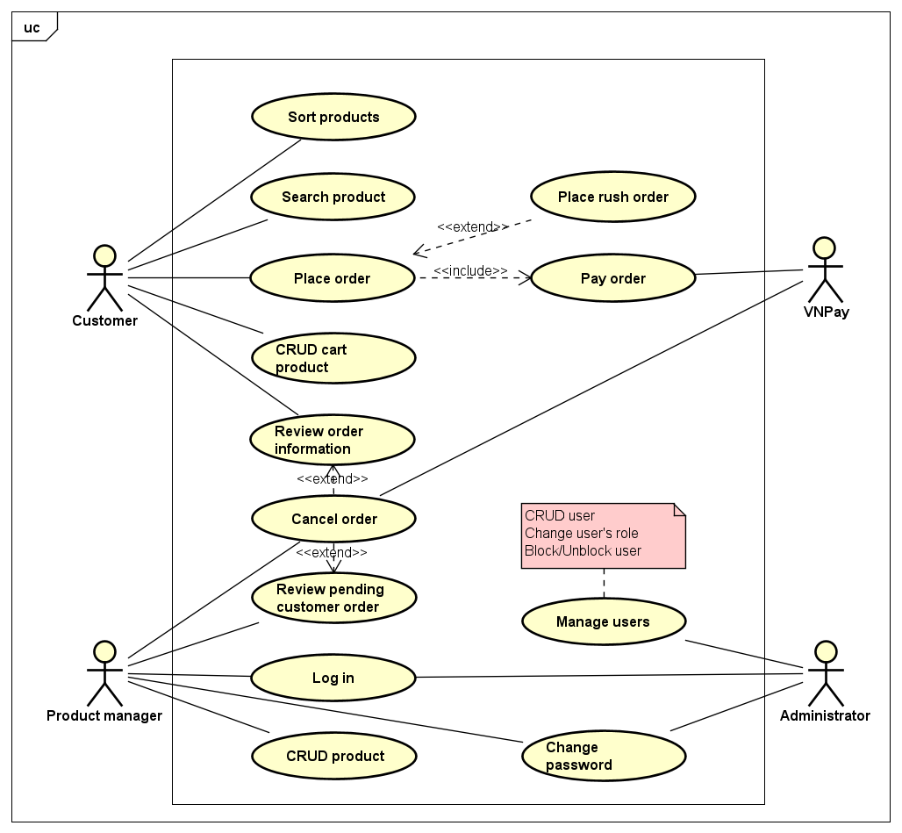

Business process
First, use case “Place order” is start, then at step 6, AIMs software checks that if the customer has placed rush order then use case “Place rush order” will be call. Otherwise, the “Place order” process still continues. At step 10, AIMs software will call “Pay order”.

Place order process
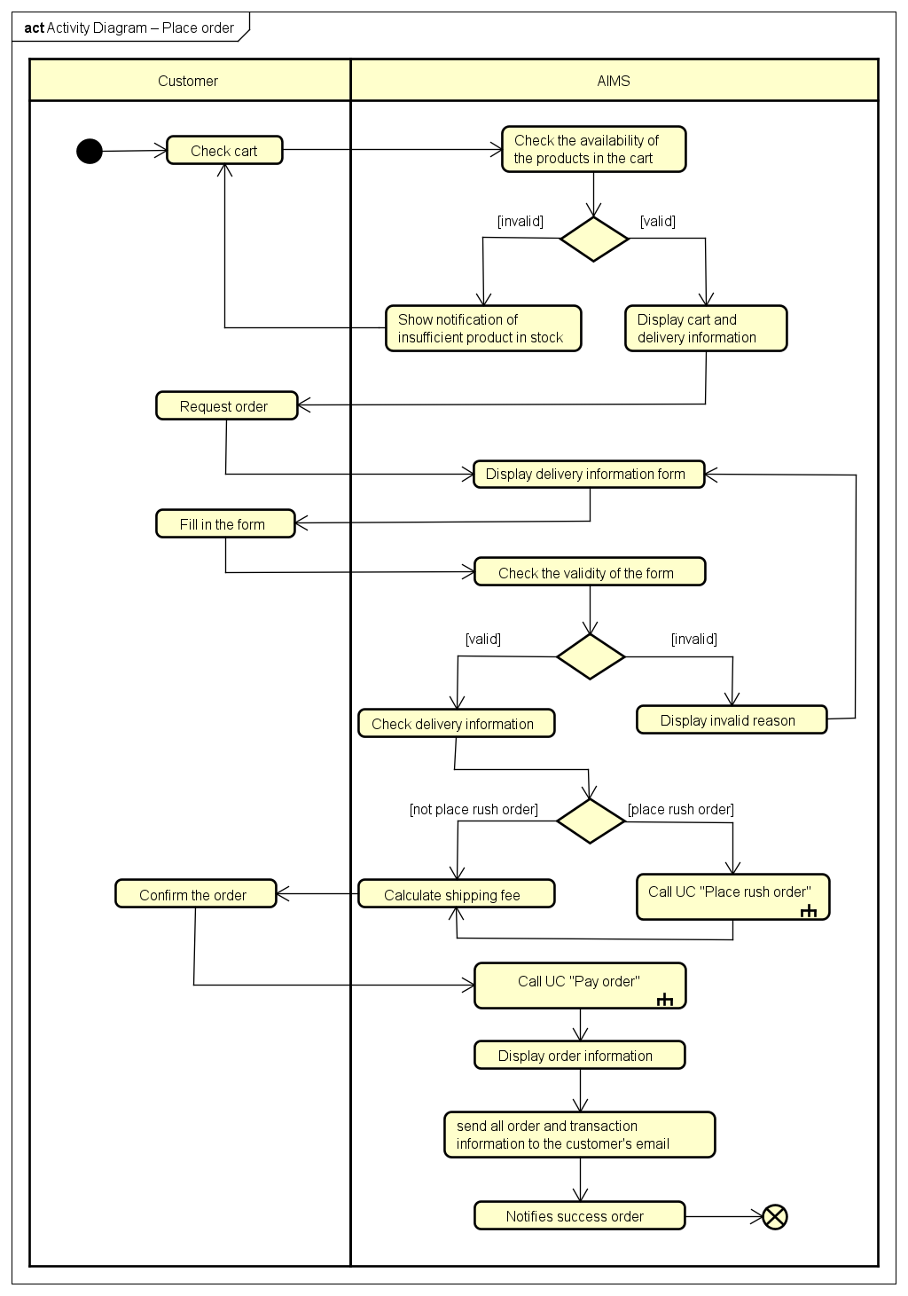

Pay order process
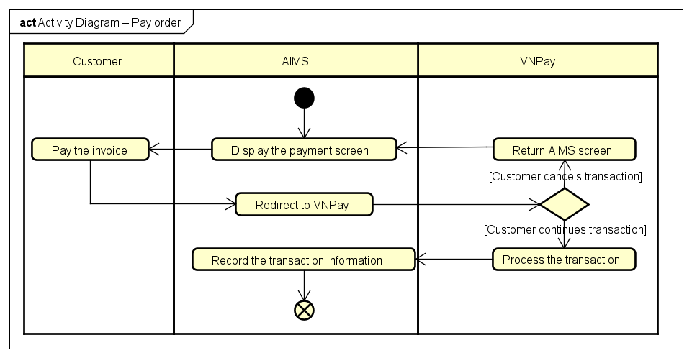

Place rush order process
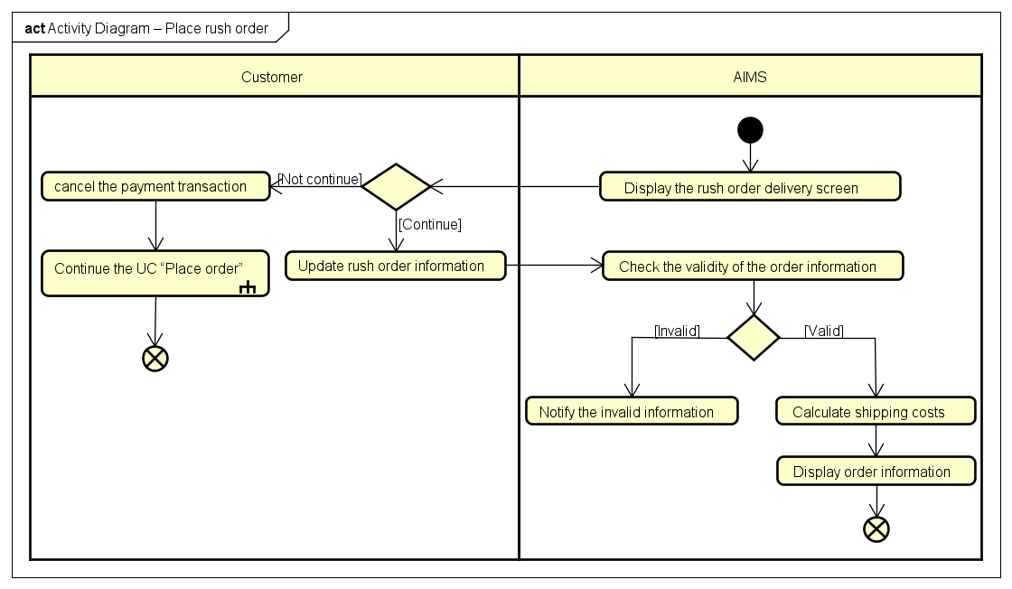

Detailed Requirements
In the AIMS Project, UC “Place Order” and “Place Rush Order” describe the interaction between customers and AIMS softwarewhen the customer wishes to place an order. Naturally, from the use case diagram, we describe how the use case starts and ends to gain the purpose of a use case, and we may think of a basic flow of the events for UC “Place (Rush) Order" as follows.

Use Case “Place order”

Use Case “Place order”
- Use case code
UC001
- Brief Description
This use case describes the interaction between a customer and AIMS when the customer wants to place an order.
- Actors
  - Customer
- Pre-conditions
The customer has products in the cart.
- Basic Flow of Events
- Customer checks cart
- AIMS checks the availability of the products in the cart
- AIMS displays cart and delivery information
- Customer requests order
- AIMS displays delivery information form
- Customer fills and confirms the delivery information (see Table 2)
- AIMS checks the validity of delivery information
- AIMS checks delivery information
- AIMS calculates shipping fee and displays receipt
- Customer confirms the order
- AIMS calls UC002 “Pay order”
- AIMS displays the order information (see Table 3, Table 4)
- AIMS sends all order and transaction information to the customer's email
- AIMS notifies successful order
- Alternative flows
Table 1 - Alternative flows of events for UC Place order
No | Location | Condition | Action | Resume location
 | At Step 3 | Insufficient quantity of product in stock | - AIMS shows notification of insufficient quantity of product in stock and requests customer to update the cart.  - Customer updates cart | 2
 | At Step 6 | Customer selects rush order delivery option | - Goes to UC003 “Place rush order” if any product supports rush order delivery. Otherwise, the process returns to step 6 | 8
 | At Step 7 | Missing or invalid information | - Requests customer to re-enter and update the information | 5
- Input data
Table 2 – Input data of delivery information
No | Data fields | Description | Mandatory | Valid condition | Example
 | Customer name |  | Yes |  | DINH VIET QUANG
 | Phone number |  | Yes | 10-digit number | 0123456789
 | Province | Choose from list | Yes |  | Ha Noi
 | Address |  | Yes |  | No 1, Dai Co Viet street, Hai Ba Trung district
 | Time |  | Yes |  | 12:00, 01/01/2024
 | Shpping instructions |  | No |  | Weekdays delivery
- Output data
Table 3 - Output data of order information and shipping fee
No | Data fields | Description | Display format | Example
 | Title | Title of a media product |  | “MTP” DVD
 | Price | Price of the corresponding product | - Positive integer  - Separate thousands by commas  - Right-aligned | 100,000
 | Quantity | Quantity of products |  | 5
 | Amount | Total price of the corresponding product |  | 500,000
 | Subtotal before VAT | Total price in the cart before VAT |  | 500,000
 | Subtotal | Total price in the cart including VAT |  | 550,000
 | Shipping fee |  |  | 40,000

Table 4 - general information of order and transaction info
No | Data fields | Description | Display format | Example
1. | Customer name |  |  | DINH VIET QUANG
2. | Phone number |  |  | 0123456789
3. | Province | Choose from list |  | Ha Noi
4. | Address |  |  | No 1, Dai Co Viet street, Hai Ba Trung district
5. | Total price | Sum of subtotal and shipping fees | Right aligned  Vietnamese currency(VND)  Vietnamese locate | 590,000
6. | Transaction ID |  |  | 12345621
7. | Transaction content |  |  | Hello 123
8. | Transaction date |  | dd/mm/yyyy | 01/01/2024

- Post-conditions: None

Use Case “Pay order”
Use Case “Pay order”
1. Use case code
UC002
2. Brief Description
This use case describes the interaction between the customer, VNPay and AIMS when the customer wants to make a payment.
3. Actors
3.1 Customer
3.2 VNPay
4. Pre-conditions
AIMS has calculated the total price to be paid.
5. Basic Flow of Events
1. AIMS displays the payment screen (see Table 2)
2. Customer asks to pay the invoice
3. AIMS redirects to VNPay to process the transaction
4. VNPay processes the transaction
5. AIMS records the transaction information (see Table 3)
6. Alternative flows
Table 1 - Alternative flows of events for UC Pay order
No | Location | Condition | Action | Resume location
1. | At Step 3 | If the customer cancels the payment transaction | - VNPay redirects to the software | 1
7. Input data
Table 2 – Input data of purchasing information
No | Data fields | Description | Mandatory | Valid condition | Example
1. | Card owner |  | Yes |  | DINH VIET QUANG
2. | Card number |  | Yes |  | 09123232134132
3. | Expiry |  | Yes | mm/yy | 12/23
 | PIN code |  | Yes |  | 246891
8. Output data
Table 3 - Output data of invoice
No | Data fields | Description | Display format | Example
1. | Title | Title of a media product |  | “MTP” DVD
2. | Price | Price of the corresponding product | - Positive integer  - Separate thousands by commas  - Right-aligned | 100,000
3. | Quantity | Quantity of products |  | 5
4. | Amount | Total price of the corresponding product |  | 500,000
 | Subtotal before VAT | Total price in the cart before VAT |  | 500,000
 | Subtotal | Total price in the cart including VAT |  | 550,000
 | Shipping fee |  |  | 40,000
 | Total price | Sum of subtotal and shipping fees |  | 590,000
 | Currency | Vietnamese currency |  | VND
 | Customer name |  |  | DINH VIET QUANG
 | Phone number |  |  | 0123456789
 | Province | Choose from list |  | Ha Noi
 | Address |  |  | No 1, Dai Co Viet street, Hai Ba Trung district
 | Transaction date |  |  | 01/01/2024
 | Shpping instructions |  |  | Weekdays delivery

9. Post-conditions: None

Use Case “Place rush order”
Use Case “Place rush order”
1. Use case code
UC003
2. Brief Description
This use case describes the interaction between the customer and AIMS when the customer wants to make a rush order delivery.
3. Actors
3.1 Customer
4. Pre-conditions
Customer chooses rush order option.
5. Basic Flow of Events
1. AIMS displays the rush order delivery screen with a list of products that support rush order delivery (see Table 2)
2. Customer updates rush order information and chooses products
3. AIMS checks the validity of the order information
4. AIMS calculates shipping costs
5. AIMS displays order information
6. Alternative flows
Table 1 - Alternative flows of events for UC Place rush order
No | Location | Condition | Action | Resume location
1. | At Step 1 | If the customer cancels the payment transaction | - Continues the UC001 – “Place order” | Use case ends
2. | At Step 3 | If the location is not in Ha Noi | - Notifies the invalid information | 2
3. | At Step 3 | Missing information | - Requests customer to fill the missing information | 2
7. Input data
Table 2 - Input data of rush order delivery information
No | Data fields | Description | Mandatory | Valid condition | Example
1. | Receiver’s name |  | Yes |  | DINH VIET QUANG
2. | Phone number |  | Yes | 10-digit number | 0123456789
3. | City | Choose from list | Yes |  | Ha Noi
4. | Address |  | Yes |  | No 1, Dai Co Viet street, Hai Ba Trung district
5. | Time |  | Yes |  | 12:00, 01/01/2024
6. | Instruction |  | No |  | Weekdays delivery
- Output data: None
- Post-conditions
Calculate delivery costs to continue printing invoice for UC001.

Supplementary specification

Functionality
Placing orders and paying orders, instead of features such as account authentication or user management.

Usability
AIMS Project is a 24/7 platform-independent system, which allows new users to easily familiarize themselves.

Reliability
The AIMS Software can also be fixed within 1 hours after any typical failure. The response time for the AIMS Software is 1 second at normal or 2 seconds during a peak load if it is not explicitly stated.

Performance
The system can serve up to 1000 customers at the same time without noticeable loss of performance and operate for an average of 300 hours without failure.

Supportability
The product manager can delete up to 10 products at once. Additionally, he is not allowed to delete or update more than 30 products due to security concerns but can add an unlimited number of products in a day.

Other requirements

